**How to create a guest account for 2024 MACCS-RAMP registration**

To register for the 2024 MACCS-RAMP User’s Group Meeting, participants must first have an account on the RAMP website. If you are not a RAMP member, you can create a guest account on the RAMP website using the following instructions:

1. Please visit <https://ramp.nrc-gateway.gov/events/october-2024-user-group-meeting> for registration. When you are in the RAMP website, you will need to click on the ‘CONTACT’ box to enter your information for a guest account to be able to register. Please see picture below with the red arrow.

1. After you click on the ‘CONTACT’ box you will see a form as shown below on the RAMP website. Please enter your information in that form and click on the ‘SEND MESSAGE’ box to create a guest account on the RAMP website. You will be contacted with your login information within 48 business hours. When you received your guest account login information, please login to the RAMP website to register for the MACCS-RAMP user’s group meeting. Please use the following link: <https://ramp.nrc-gateway.gov/form/october-2024-international-ramp-> and choose Meetings | October 2024 User Group Meeting to register.

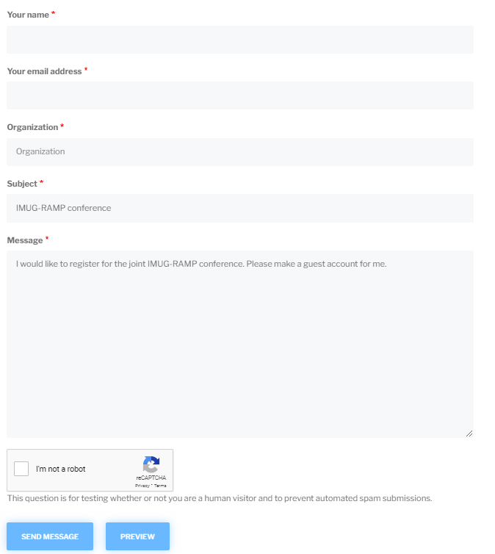

1. If you would like access to the RAMP codes, including the use of the RAMP codes during the in-person workshops, you can apply for a RAMP membership by going to the membership tab on the RAMP website.